**POMODORO**

**(TIME MANAGEMENT SYSTEM)**

**PROJECT BY**

* **RAHUL MISTRI**

**Index**

|  |  |  |
| --- | --- | --- |
| **SR.NO** | **PARTICULARS** | **PAGE NO** |
| 1 | INTRODUCTION | 4 |
|  | INTRODUCTION TO SYSTEM | 6 |
|  | SCOPE OF SYSTEM | 7 |
|  | PROPOSED SYSTEM | 8 |
| 2 | SYSTEM ANALYSIS | 10 |
|  | FACT FINDING TECHNIQUE | 11 |
|  | FEASIBILITY STUDY | 14 |
|  | HARDWARE REQUIREMENTS | 15 |
|  | SOFTWARE REQUIREMENTS | 15 |
| 3 | SYSTEM DESIGN | 16 |
|  | CLASS DIAGRAM | 17 |
|  | USE CASE DIAGRAM | 18 |
|  | ACTIVITY DIAGRAM | 19 |
|  | FILE DESIGN | 20 |
| 4 | FXML DESIGN (SCREEN SHOTS) | 21 |
| 5 | LIMITATIONS | 27 |
| 6 | ADVANTAGES AND DISADVANTAGES | 28 |
| 7 | FUTURE ENHANCEMENT | 29 |
| 8 | BIBLOGRAPHY | 30 |
| 9 | ACKNOWLEDGEMENT | 31 |

**INTRODUCTION**

**POMODORO TIME MANAGEMENT TECHNIQUE**

"The Pomodoro Technique is a time management method developed by Francesco Cirillo in the late 1980s. The technique uses a timer to break down work into intervals, traditionally 25 minutes in length, separated by short breaks. Each interval is known as a pomodoro, from the Italian word for 'tomato', after the tomato-shaped kitchen timer that Cirillo used as a university student.  
  
The technique has been widely popularized by dozens of apps and websites providing timers and instructions. Closely related to concepts such as timeboxing and iterative and incremental development used in software design, the method has been adopted in pair programming contexts."

*Source: Pomodoro Technique -* [*https://en.wikipedia.org*](https://en.wikipedia.org/wiki/special:search/Pomodoro%20Technique)

**There are six steps in the original technique:**

1. Decide on the task to be done.
2. Set the pomodoro timer (traditionally to 25 minutes).
3. Work on the task.
4. End work when the timer rings and put a checkmark on a piece of paper.
5. If you have fewer than four checkmarks, take a short break (3–5 minutes), then go to step 2.
6. After four pomodoros, take a longer break (15–30 minutes), reset your checkmark count to zero, then go to step 1

**Introduction to System**

“POMODORO (TIME Management System)”is a time management system which can be used by anyone who is trying to manage their time efficiently while focusing on tasks important at hand.

POMDORO (TIME Management System)” capable of getting you into the zone of productivity by giving you precise timers with ambient ocean music to get you into focus mode.

* Performing user authorization before allowing user to actually start & utilize the timer.
* Maintaining users information.

**SCOPE OF SYSTEM**

* Our System is helpful for Common people to get better at focus with a recognized time management technique.

* This system helps you to be productive.

* This system also provides background music.

* This system helps to block out your surrounding by music and timers so that you can focus on the main task.

**PROPOSED SYSTEM**

* The proposed system that will be a automated task of the POMODORO Time Management technique used by millions of people.
* Maintaining the timer would be easy as compared to manual timer
* The proposed system will maintain all the things related to timer .

**FEATURES OF PROPOSED SYSYTEM**

* Easy to use.
* Speedy setup of 25 min timers.
* User friendly UI for easy interactions.
* Made with JAVAFX for clean look.
* Independent of Operating System.

**OBJECTIVES**

* Make it easy to manage time
* Cut down on Interruptions.
* Get tasks done faster and on time.

**SYSTEM**

**ANALYSIS**

**FACT FINDINGTECHNIQUES**

As data collection is an important part of analysis, we accomplished this using fact finding technique to gather from users.

The following fact finding techniques is used for the purpose are

1 Interview

2 Questionnaires

3 Record reviews

4 Observations

**INTERVIEW**

We used this technique frequently in the system analysis after questionnaires. These interviews were unstructured. I choose some people in the college who were either the my batch mates or user in some activity related with the project. I interviewed them many times. This helped us understand all the stages involved in activity.

I used interviews for collection from individual and groups who are generally the current users of the existing system i.e. students and creative professionals.

**QUESTIONNARIES**

I used this technique in the initial and final phase of my project.

I conducted this session by asking question to the Administrator of the manual system, I prepared questionnaires to get some basic information about the current system. We could find out the work structure of the management system and it’s functioning. In the final stages I used the questionnaires to get some numerical data that was required or was missing after all the observations. Questions asked were both open ended and close ended, which were related to user’ interaction with current system, updating and rules for record. Maintenance reports generated by current system complications in the system as per user.

**OBSERVATION**

While finding the facts i keenly observed all the activities in the when managing time. I paid attention to the transaction, friction between setting timers and handling all the data manually. Observation helped me in finding out the actual way of functioning apart from the ideal or desired. This helped me majority in the interface design.

This method helps me to obtain first hand information on how the activities are carried out

**FEASIBILITY STUDY**

* One of the most important outcomes of preliminary investigation is the determining whether the system is feasible. The feasibility study for this system was carried out in following aspects.

1. **Technical Feasibility:**

The assessment is based on an outline design of system requirements in terms of Input, Processes, Output, Fields, Programs, and Procedures. This can be quantified in terms of volumes of data, trends, frequency of updating, etc. in order to estimate whether the new system will perform adequately or not. Technological feasibility is carried out to determine whether the company has the capability, in terms of software, hardware, personnel and expertise, to handle the completion of the project.

2. **Operational Feasibility:**

Operating feasibility is concerned with the acceptability of the system. Concerned to this system is user friendly, i.e. user will able to handle system. It will not cause any trouble. It is acceptable with its advanced features.

3**.Economical feasibility**:

Economical feasibility considers the cost and benefits analysis of proposed system. Economically our system is feasible. It helps to maintain the daily records of customers with its date.

**HARDWARE AND SOFTWARE REQUIREMENT**

Minimum Hardware Requirements

* Processor :- Pentium 4,1.8GHZ
* RAM :- 512MB.
* HDD :- 40 GB.
* Monitor :- Any Color Monitor

Minimum Software Requirement

* Operating System: - Windows XP,7,8,10
* Language :- JAVA SE 8
* Database :- MS-Access

**SYSTEM**

**DESIGN**

**Class Diagram :**

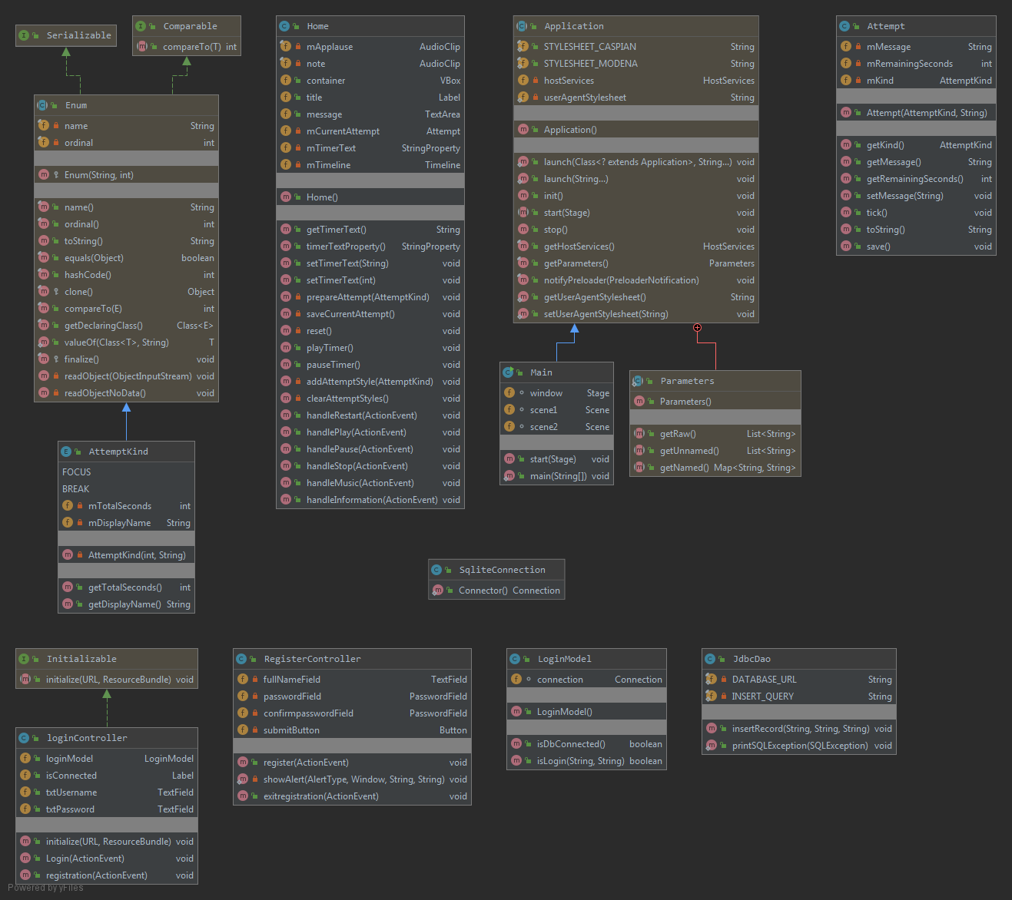

**F - Field , M* - Constructor , M – Method , C - Class**

**Use Case Diagram :**

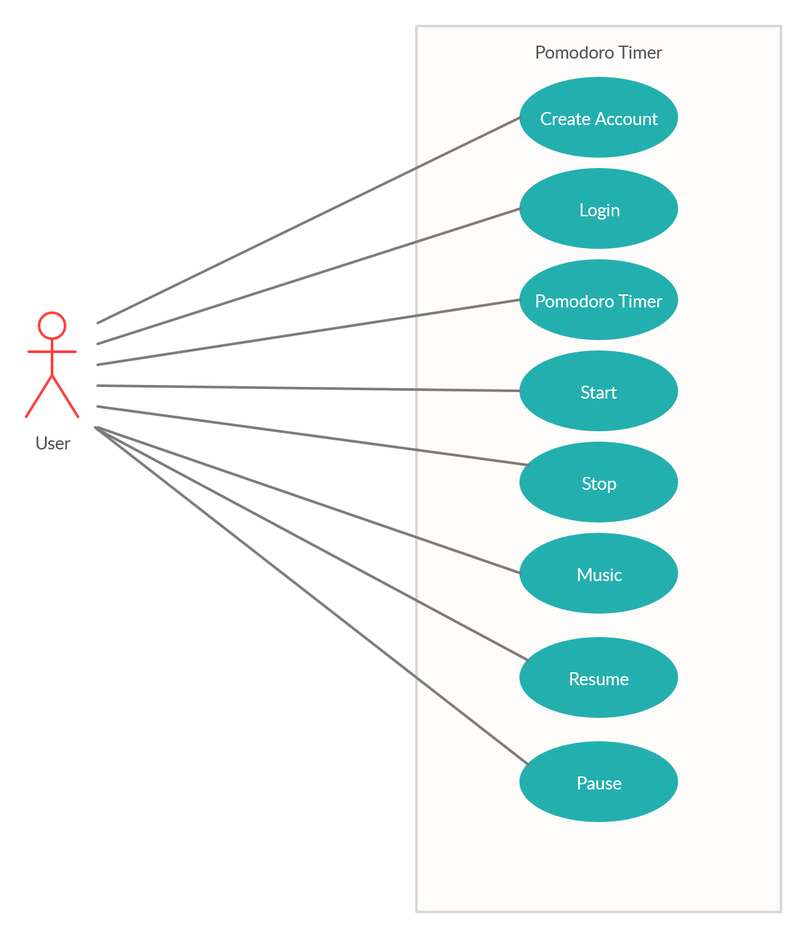

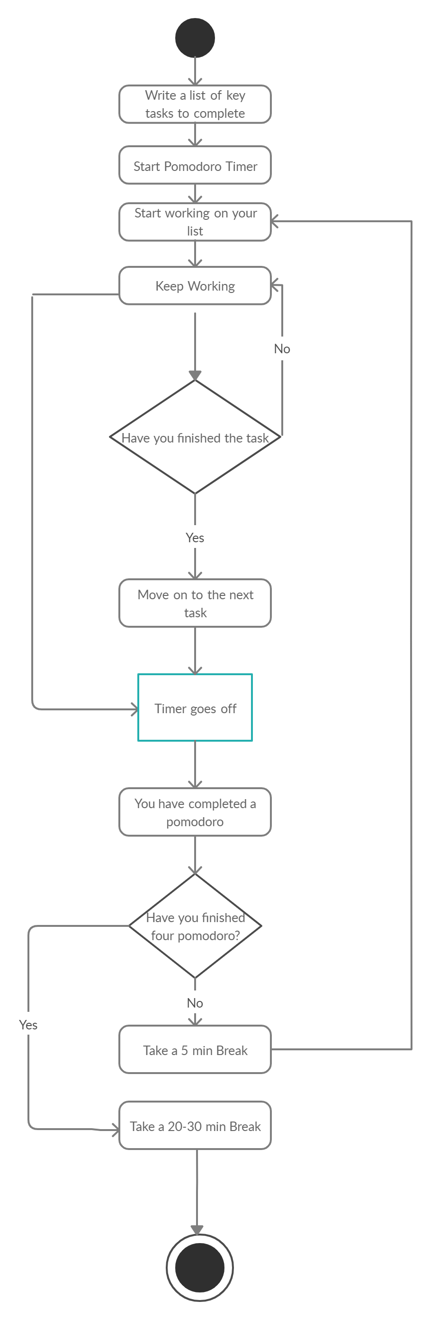**Activity Diagram :**

**FILE DESIGN :**

Login:

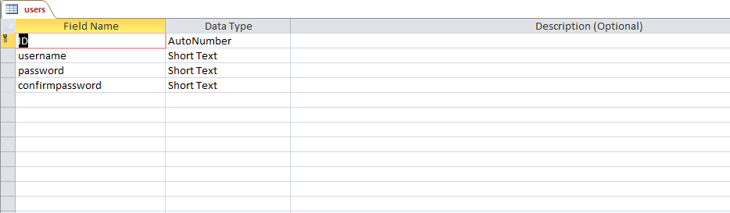

**JAVAFX**

**FXML DESIGNING**

Login FXML:

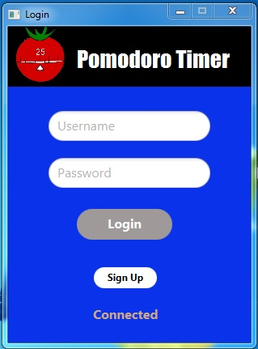

Registration FXML:

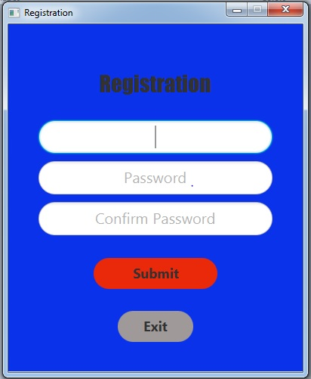

Pomodoro FXML:

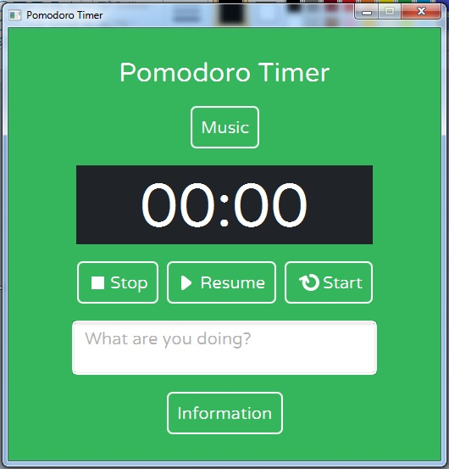

Focus Time FXML:

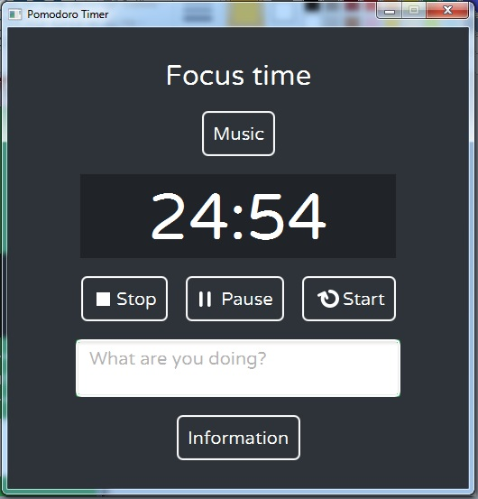

Break Time FXML:

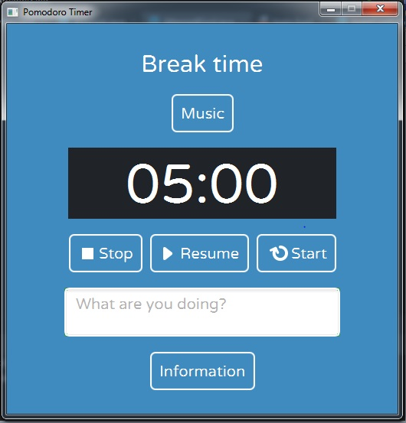

**LIMITATIONS**

* The system cannot work on headless machines.
* Doesn’t support black and white monitor.
* Our System is limited to small group of people.
* This system is design to be standalone & does not work on network site.

**ADVANTAGES**

**1.User Friendly :**

The system has got much simplified screen which makes the system fast enhances quick and accurate data.

**2**.**Free of manual setting:**

This automates the task of manual setting of timer for pomodoro technique.

**4.Easy to learn:**

This system is easy to understand, this mainly due to simple functionality.

**DISADVANTAGES**

1. **This system is costly**

This system requires hardware and software…while it could have been done via a normal stop watch.

1. **The user should have basic computer knowledge**

As this is a computer based system so user must have basic knowledge of computer.

1. **Tracking of activity**

As the tracking of activities are done manually we cannot give statistical information.

**FUTURE**

**ENHANCEMENT**

As we have already mentioned that the system consists of all the new and advanced facilities given by JavaFX Design Framework and Java Language

But as the time never stops and the man should change with time. As the man will change their requirement will also be changed time by time.The most important thing of this Software is that it is further improved with having change in its current setting

**BIBLIOGRAPHY**

* Java Programming (Nirali)
* Advance Java (Nirali)
* [www.stackoverflow.com](http://www.stackoverflow.com)
* docs.oracle.com/javafx/
* docs.oracle.com/en/java/